MongoDB Assignment-1

# Query / Find Documents

# query the movies collection to

# get all documents

# get all documents with writer set to "Quentin Tarantino"

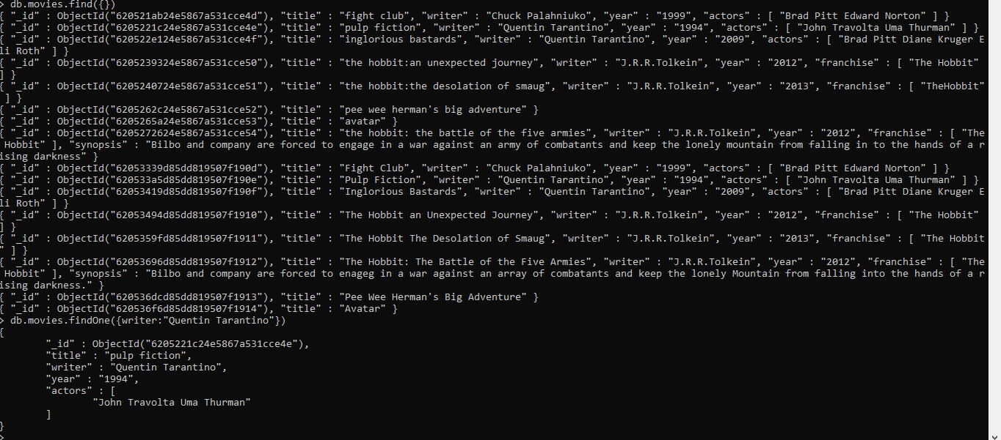

# 3. get all documents where actors include "Brad Pitt"

# 4. get all documents with franchise set to "The Hobbit"

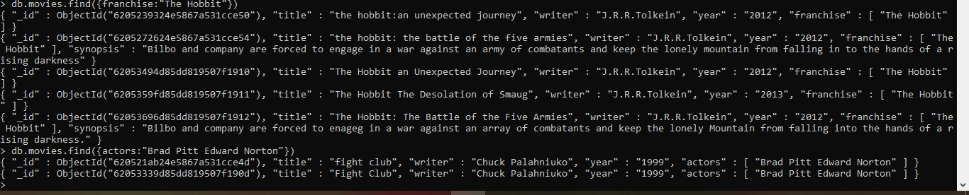

# 5. get all movies released in the 90s

# 6. get all movies released before the year 2000 or after 2010

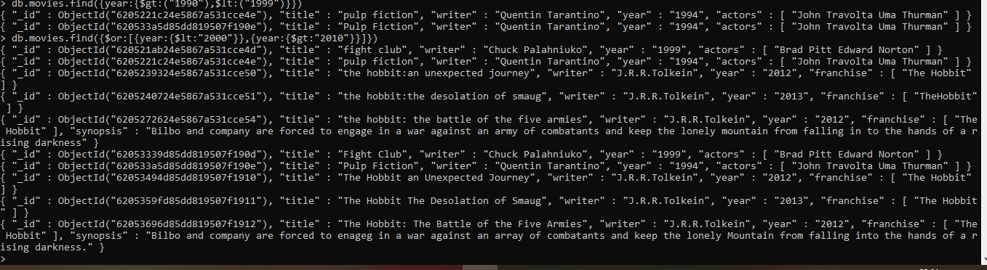

# Update Documents

# 1. add a synopsis to "The Hobbit: An Unexpected Journey" : "A reluctant hobbit, Bilbo Baggins, sets

# out to the Lonely Mountain with a spirited group of dwarves to reclaim their mountain home -

# and the gold within it - from the dragon Smaug."

# 2. add a synopsis to "The Hobbit: The Desolation of Smaug" : "The dwarves, along with Bilbo

# Baggins and Gandalf the Grey, continue their quest to reclaim Erebor, their homeland, from

# Smaug. Bilbo Baggins is in possession of a mysterious and magical ring."

# add an actor named "Samuel L. Jackson" to the movie "Pulp Fiction"

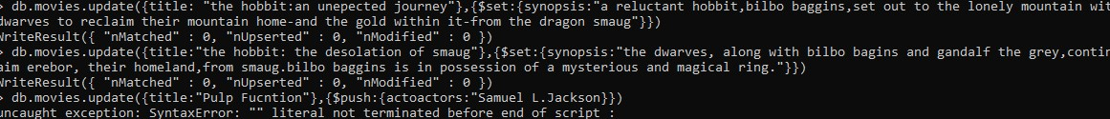

# Text Search

# find all movies that have a synopsis that contains the word "Bilbo"

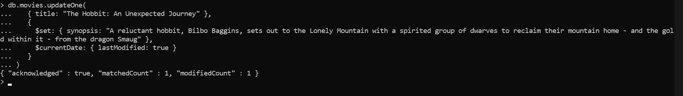

# find all movies that have a synopsis that contains the word "Gandalf"

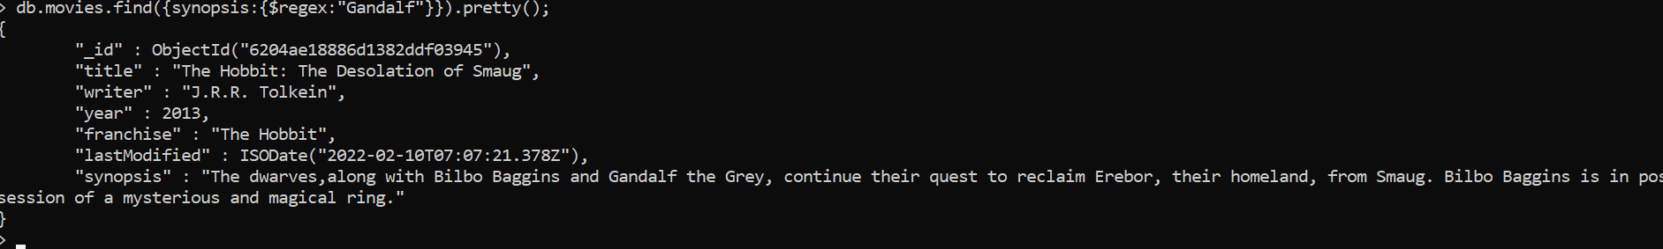

# find all movies that have a synopsis that contains the word "Bilbo" and not the word "Gandalf"

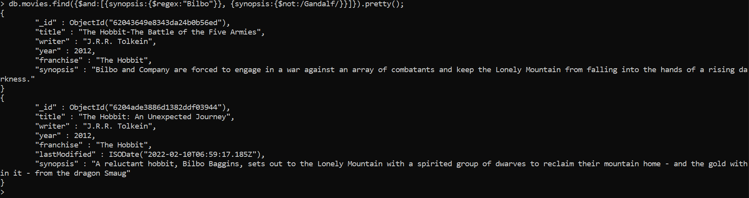

# find all movies that have a synopsis that contains the word "dwarves" or "hobbit"

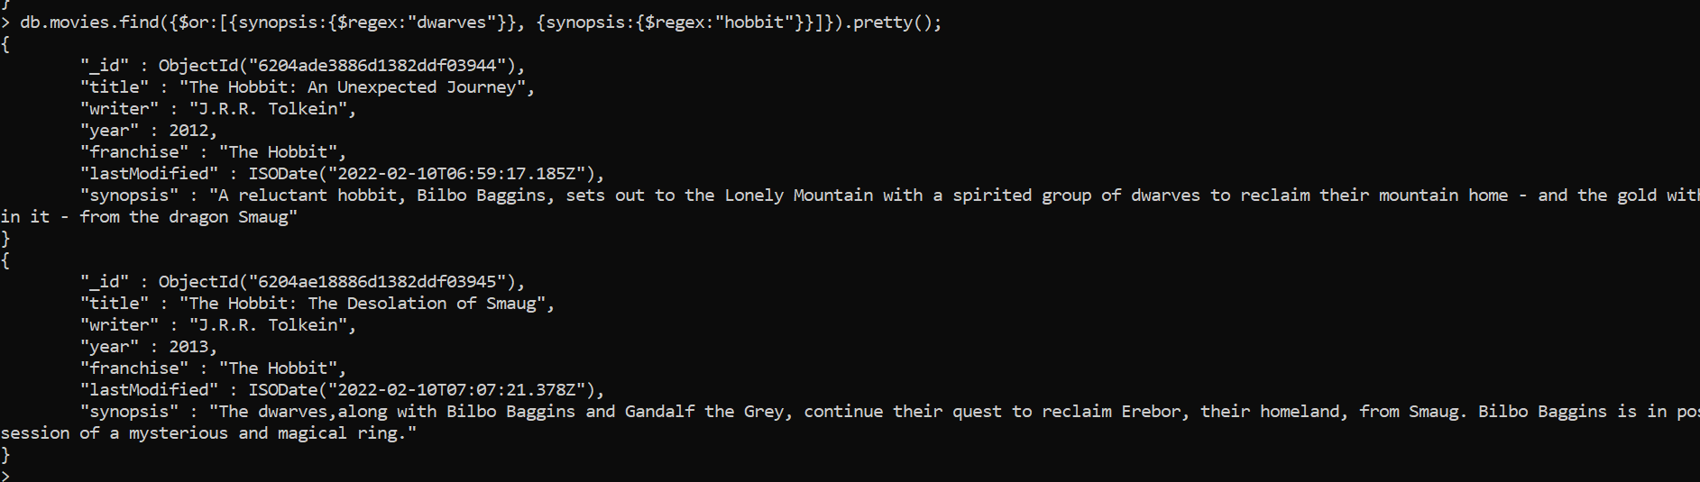

# 5.find all movies that have a synopsis that contains the word "gold" and "dragon"

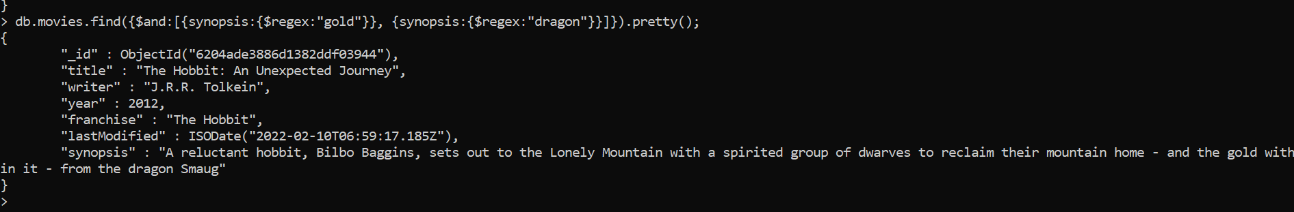

# Delete Documents

# 1. delete the movie "Pee Wee Herman's Big Adventure"

# 2. delete the movie "Avatar"

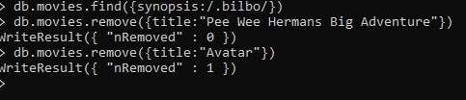

# Relationships

# Insert the following documents into a users collection

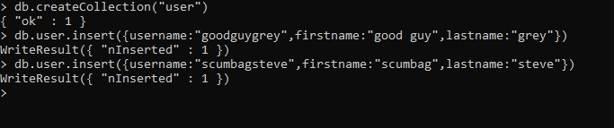

# Insert the following documents into a posts collection

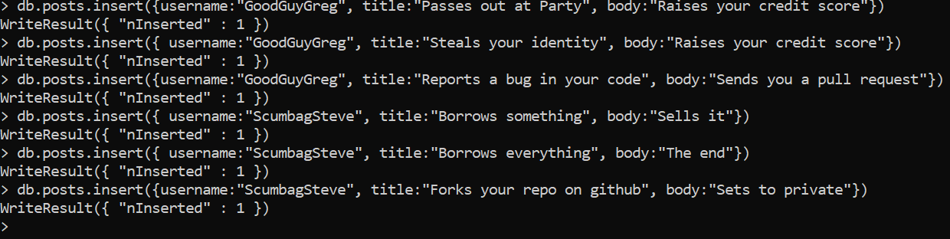

# Insert the following documents into a comments collection

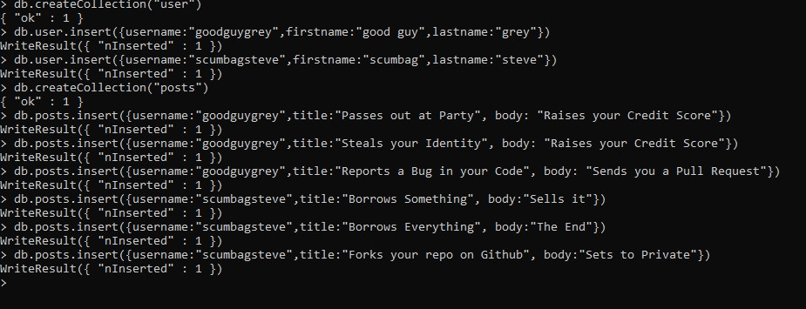

# Querying related collections

# 1. find all users

# 2. find all posts

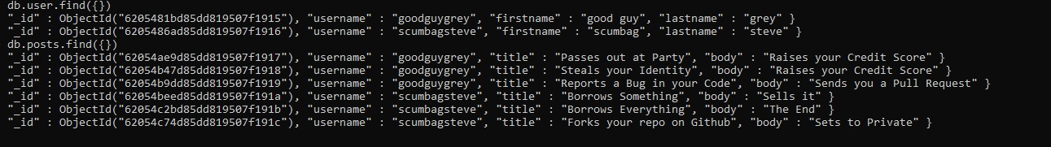

# find all posts that was authored by "GoodGuyGreg"

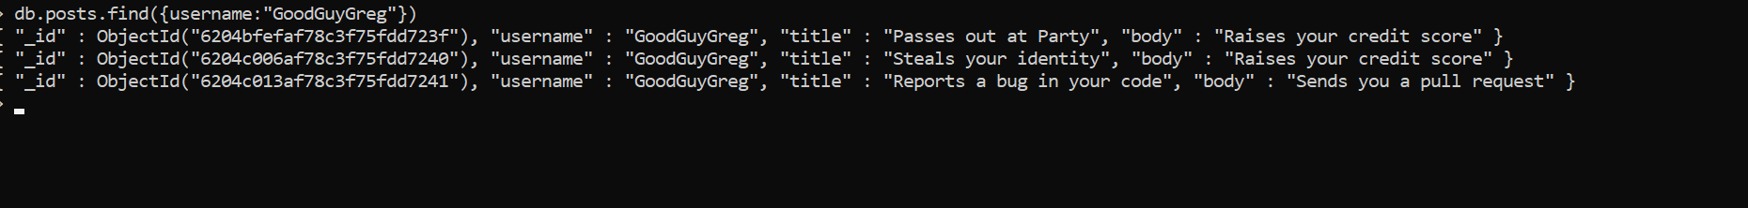

# find all posts that was authored by "ScumbagSteve"



# find all comments

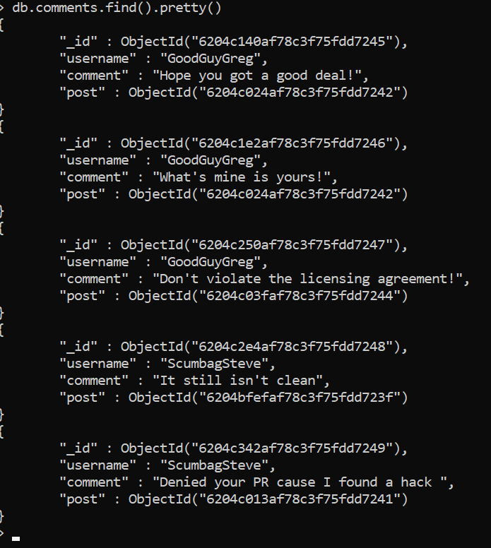

# find all comments that was authored by "GoodGuyGreg"

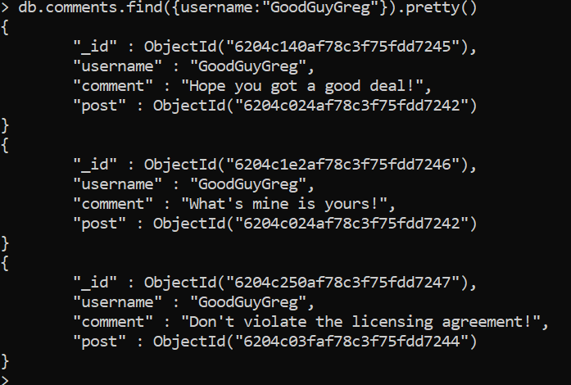

# find all comments that was authored by "ScumbagSteve"

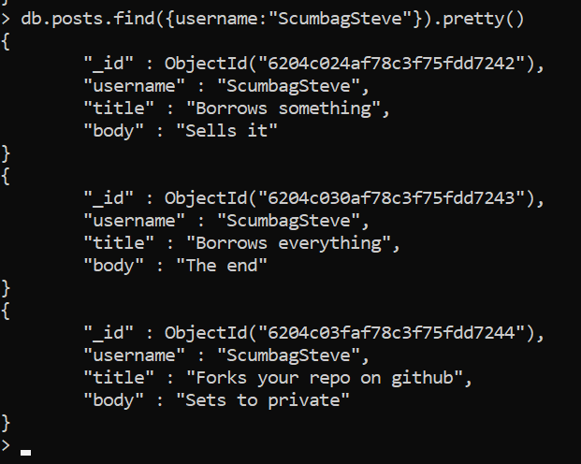

# find all comments belonging to the post "Reports a bug in your code"

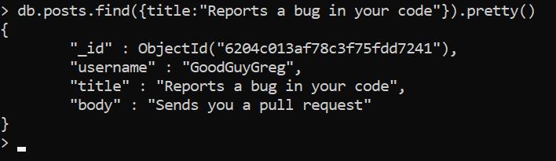

# MongoDB Assignment-2

# Atlanta Population

# use db.zipcodes.find() to filter results to only the results where city is ATLANTA and state is GA.

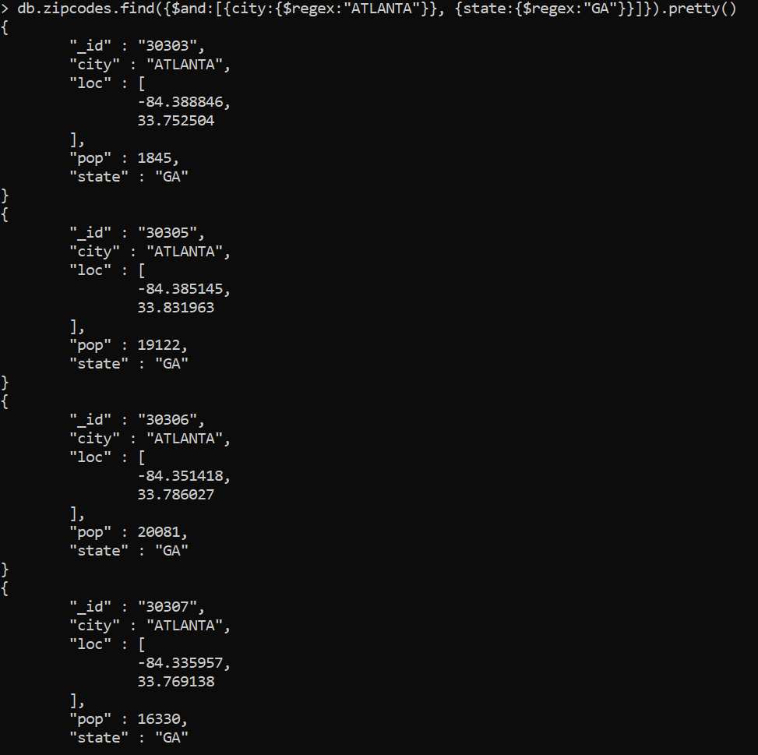

# 2. use db.zipcodes.aggregate with $match to do the same as above.

# 3. use $group to count the number of zip codes in Atlanta.

# 4. use $group to find the total population in Atlanta.

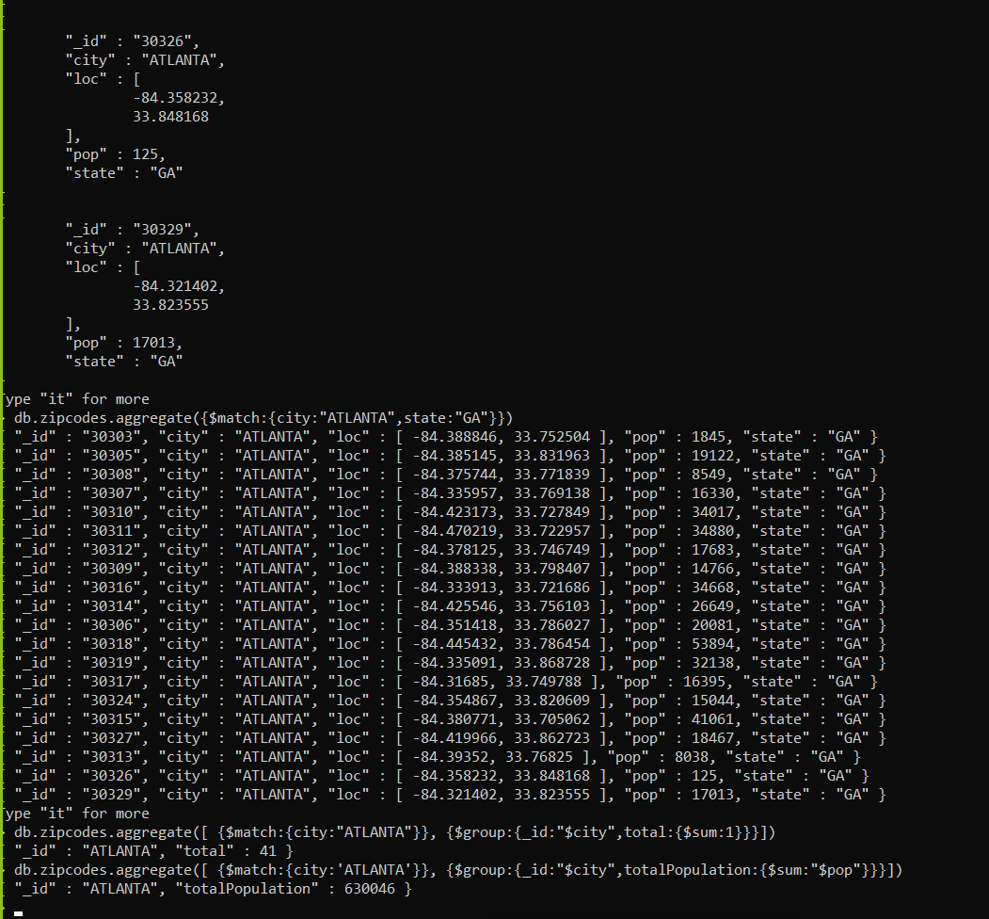

# Populations By State

# 1. use aggregate to calculate the total population for each state

# 2. sort the results by population, highest first

# 3. limit the results to just the first 3 results. What are the top 3 states in population

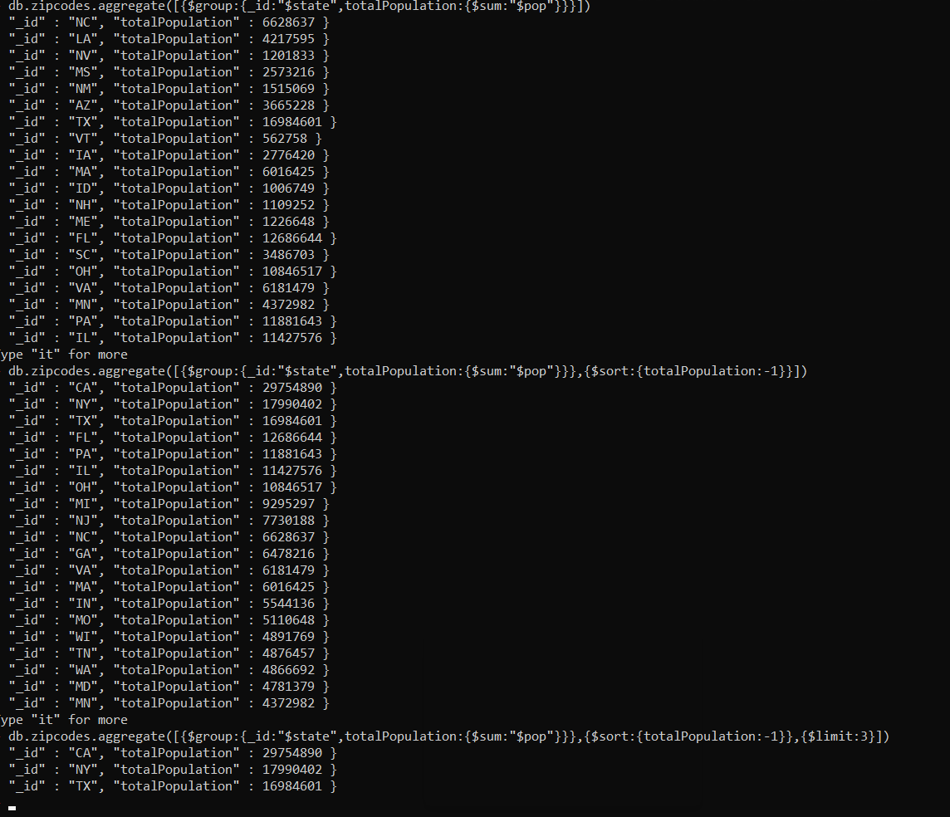

# Populations by City

# 1. use aggregate to calculate the total population for each city (you have to use

# city/state combination). You can use a combination for the _id of the $group: {

# city: '$city', state: '$state' }

# sort the results by population, highest first

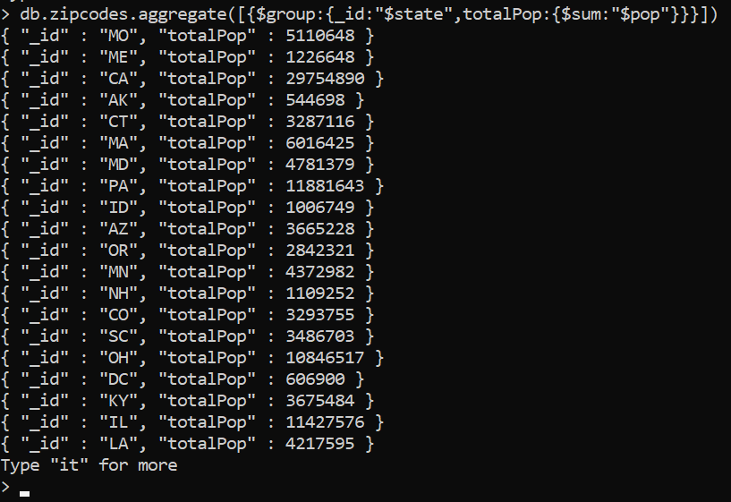

# Bonus

# 1. Write a query to get the average city population for each state.

# 2. What are the top 3 states in terms of average city population

# 